SOLO MOTORSPORTS INC.
96-04 TACOMA, 96-02 4RUNNER, 00-06 TUNDRA, 01-07 SEQUIOA
14” LONG TRAVEL PARTS LIST/INSTALLATION NOTES
Before beginning your installation of Solo Motorsports parts, familiarize yourself with the parts and fully read the instruction notes -- safety is of the upmost importance. Use fully functioning jack stands to make sure your vehicle is stable to work under or around and secure the tires. Disconnect the battery before welding to the vehicle.
LCA (LOWER CONTROLL ARMS)
8 – Short Bushings Anti-seize the LCA barrels, center sleeves, alignment factory cam bolts/lower lockout bolts, and add a little anti-seize to the frame where the LCAs will pivot.
4 – ¾ ID x 2 ½ Long Inner Sleeve
4 – ½ x 2 ¾ Bolts For coilover and bypass lower shock bolts
2 – ½ x 1 ¼ Bolts For limit strap tab
12- ½ Washers
6 – ½ Stover Nuts
DO NOT TIGHTEN THE LOWER CONTROL ARM PIVOT BOLTS UNTIL YOUR VEHICLE IS BACK ON THE GROUND AND AT STATIC RIDE HEIGHT. Failure to do so will result in premature LCA bushing wear, alignment issues, and possible noises when suspension moves. Make sure your factory ball joint is tight to LCA to factory specifications and NEW cotter pin is in the castle nut. Make sure your 4 ball joint factory bolts that attach to the lower part of factory spindles are tight using high-strength green or red thread locker.
UCA (UPPER CONTROLL ARMS)
4 – ¾” Heim Joints Anti-seize before putting in misalignments
As a baseline starting point, screw in ¾” heims and position the FRONT (front of truck) ¾” heim joints with about 4-5 threads showing with the jam nut hand tight. The REAR ¾” heim joints at bout 1-2 threads showing with the jam nut hand tight. Again, this is a baseline starting point. Before moving vehicle, tighten the ¾” heim jam nuts on the UCAs.
Confirm with your alignment shop if they are willing to remove/replace your coil bucket cross-shaft bolt and adjust the UCA’s with 3/4” heim joints to adjust the camber or caster. If they cannot or do not want to do this, move on to a different shop. Best alignment shops are the “old school” shops that use turntables, tape measure, magnetic camber/caster gauge and put the steering wheel as straight as possible. Another resource for an off-road alignment would be an off-road shop that uses a laser alignment machine and IS familiar with off-road alignments. Most alignment shops that us laser-guided alignment machines are NOT familiar with off-road alignment and may not be able to align your front end. Do a little research and call ahead to ask if your local alignment shop that uses a laser-guided alignment machine asking if they can perform an off-road alignment to align your front end as best as possible based on your vehicle’s frame condition.
4 – ¾” Heim Jam Nuts
4 – ¼” Cross Shaft Spacers Be sure to paint. (See notes immediately below)
4 – 3/8” Cross Shaft Spacers Be sure to paint. (See notes immediately below)
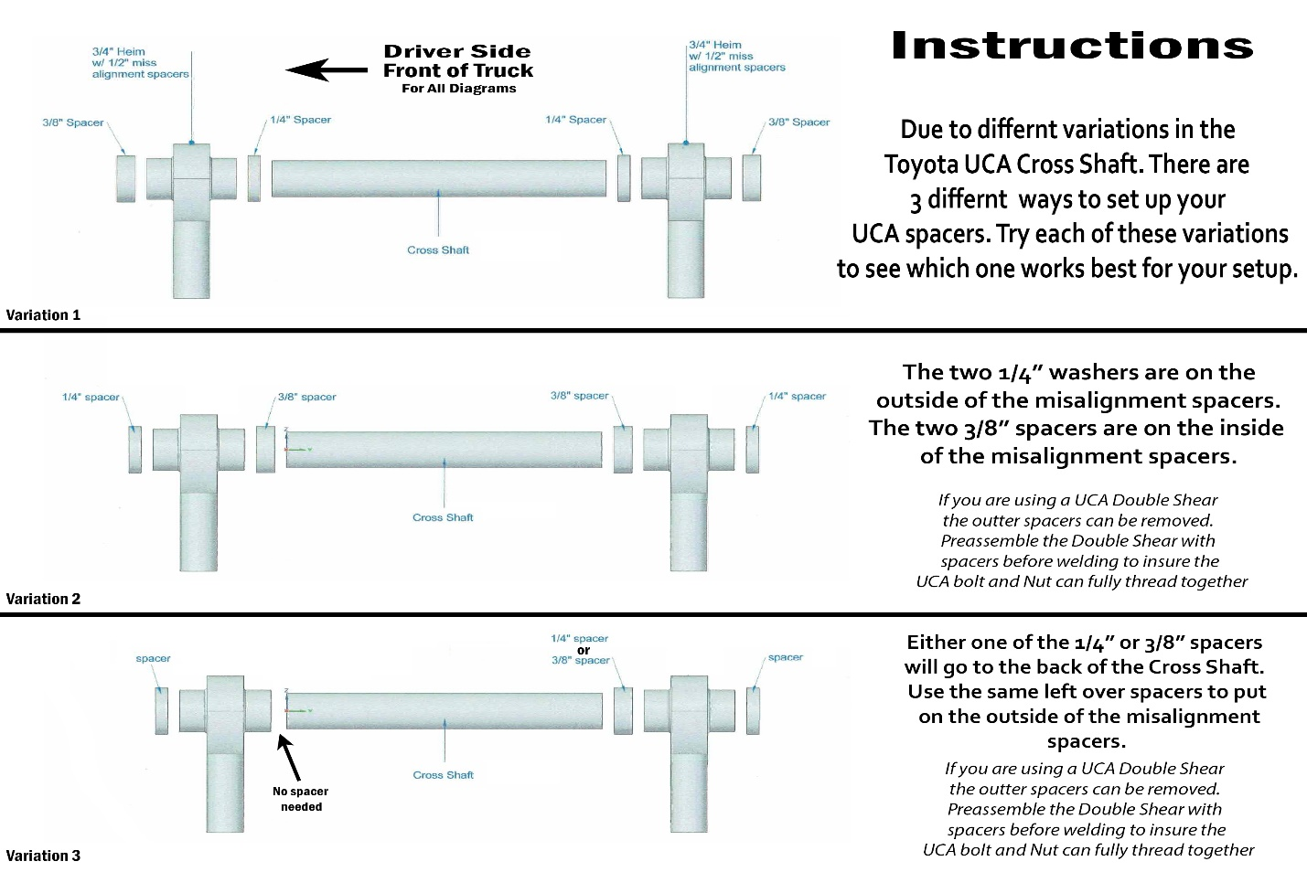
**Outside of stainless steel misalignment heims may only need 1x spacer on front side of coil bucket/UCA heim. Some spacers may NOT be necessary depending on manufacture plant location regardless if the vehicle’s coil bucket was made in Japan or America. The inner spacers that go in between the heim joint and the cross shaft have to be the same on the front and back of the cross shaft, so that the UCA is centered.
***If using Weld-it-yourself WIY UCA Double-Shear kit -- which is recommended to keep the UCA cross shaft bolt from bending with offroad use -- position the front plates (bolt head side) against the stainless steel misalignment and position the rear plates (nut side) against the stainless steel misalignment. BEFORE WELDING DISCONNECT THE CAR BATTERY. Tack weld accordingly. When welding plates, remove UCA and put spacers or oversize nuts or 1” tubing to take up the gap making sure there is about 1/16” wider added so the plates do not bend in towards the coil bucket making it difficult to reinstall the UCAs.
8 – ¾” to 9/16” Stainless Steel Misalignments Anti-seize before putting in misalignments
2 – 1” Uniballs Anti-seize before putting in misalignments
2 – 1” Uniball C-Clips
2 – Spindle Slugs Press out stock upper ball joint. Press into stock spindle making sure the C-clip is in the factory spindle grooves.
2 – Spindle Slug C-Clips
2 – 5/8 Tall Misalignments Anti-seize inside and out (part that goes into the 1” uniball on top of uniball on UCA)
2 – 5/8 Short Misalignments Anti-seize inside and out (part that goes on top of spindle into the 1” uniball or bottom side of uniball on UCA)
2 – 5/8 x 5” Bolt
4 – 5/8 AN Washers
2 – 5/8 Stover Nuts

TOP SHOCK MOUNTS
2 – Top Shock Mounts
2 – ½ x 4 Hex Bolts Anti-seize bolt. Install bolts to Top Shock Mount Plate to Coilover Shock prior to putting into coil bucket
2 – ½ AN Washers AN washers go onto the nut side only of the Bolts
2 – ½ Stover Nuts
6 – 3/8 x 1 ½ Bolts Bolts go to top shock mount plate then through the coil bucket. The best way is to have the bolts go from bottom up to the coil bucket and tighten the bolts down with the stover nuts and washers on top. Having 1 extra person to assist will help make it easier to install. Check clearance or clock hose fitting and hose by cycling suspension with either shock in place with NO COILS if possible. If hose needs to be routed to a “natural” position for clearance, carefully loosen the fitting/jam nut on the top of the coil over shock just enough to rotate try not to allow any oil to discharge. Retighten fitting/jam nut.
12- 3/8 Washers
6 – 3/8 Stover Nuts
EXTRAS
1 Pr - Brake Lines
96-04 Tacoma uses a copper crush washers on both sides of banjo fittings at calipers. 96-02 4Runner, 00-06 Tundra, 01-07 Sequoia use threaded fittings at caliper. Check for clearance turning left/right.
1 Pr – Steering Adjusters Anti-seize female adjuster threads. If you are using stock inner/outer tie rods, this would be a great time to replace them.
1 Pr – 14” Limit Straps
When welding the upper limit strap tab, be sure that your 4wd axle inner constant velocity CV joint at the clamshell differential will make a full 360 degree rotation at your desired full droop so as not to BIND the inner CV joints. 14” limit straps will stretch with un-sprung weight (tires, coil over shocks, A-arms, etc. at full suspension droop) about 1.25-1.5”. After installation, droop suspension until strap is tight. Then tighten bolts. Some 4wd models depending on frame and/or front clamshell differential mount condition may NOT achieve a full 14” of wheel travel. Wheel travel is measured at the outer most end of your hub and not the shock shaft.
2 – Top Limit Strap Tabs Weld on the side of the frame for full suspension droop set up.
Let suspension fully drop and then tighten the upper/lower bolts so limit strap is in its “natural” position so as not to chafe the strap material.
2 – ½ x 1 ½ Bolts For upper limit strap
4 – 1/2 Washers
2 – ½ Stover Nuts
4 – Reservoir weld-on clamps
Weld clamps towards the lower front part of frame just behind the front frame body mount so to leave room to charge the reservoirs at the Schrader valve. Reservoirs can be safely rotated for desired position with NO nitrogen or not charged. Charge as soon as possible. DO NOT DRIVE VHECHICAL WITHOUT NITROGEN IN THE SHOCK, or add compressed air to temporarily get your vehicle to a location that has nitrogen.
4 -- #36 hose clamps Goes around reservoirs
**Nitrogen charge shocks accordingly to recommended manufacture PSI.
4wd Axles
Remove existing factory axles. 00-06 Tundra and 01-07 Sequoia custom Solo Motorsports 4wd axle shafts will only work with factory inner/outer constant velocity joints. Take the axle shafts to a CV axle rebuilding shop requesting rubber inner/outer CV boots.
On the 96-02 4Runner and 96-04 Tacoma vehicles, the axles will be ready to install. It is possible to clearance pad-sand the inner CV joint housing that connects to the differential for a little more suspension droop. Again, at full suspension droop making sure the inner CV joint can safely rotate 360 degrees without any bind. Refer to setting up the upper limit strap frame mount for more information at the bottom of page 3 under “Limit Straps”.
Upon completion, set your desired coilover preload or ride height before alignment. Do a rough tape measure toe adjustment with the inner/outer tie rods (have a second person help measure in the same position on the tire front and back). If the vehicle lifts up when moving forward, the tires are toed or turned in too much. If the vehicle plows or goes down when moving forward, the tires are toed or turned out too much. If the top of the tire has positive camber or the top of the tire is positioned outwards, then more preload or 1-3 full turns on the coilover adjusting ring on your coilover shocks
After alignment is to your satisfaction and AFTER your FIRST off-road adventure, you may need to possibly add 1-2 full turns on your coilover shocks to adjust ride height. This is normal as the coils have settled. 1-2 full turns on your coilover shocks should not affect your alignment.

SAFETY FIRST
Check ALL hardware bolts after 300 miles. Do regular maintenance bolt checks before and after each off-road adventure.
Call for any technical questions Monday-Thursday 7am-5pm Pacific Standard Time 626-966-7656 or email inf@solomotorsports.com. Please allow 1-48 hours for a response.
Thank you for your purchase and continued support for Solo Motorsports Inc. Safe adventures and enjoy!!

